Question-1:
The quality assurance checks on the previous batches of drugs found that — it is 4 times more likely that a drug is able to produce a satisfactory result than not.
Given a small sample of 10 drugs, you are required to find the theoretical probability that at most, 3 drugs are not able to do a satisfactory job.

a.) Propose the type of probability distribution that would accurately portray the above scenario, and list out the three conditions that this distribution follows.
b.) Calculate the required probability.

Answer:

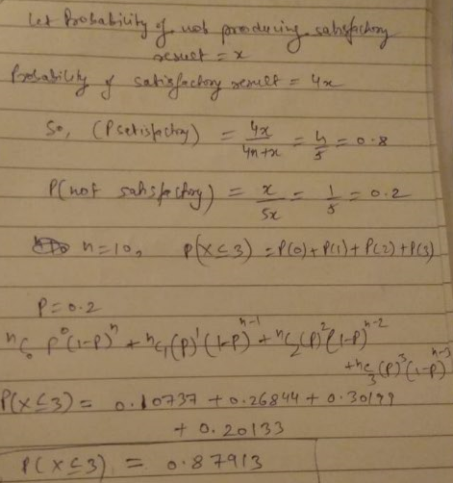

In above solution, consideration of overall population, and mentioned the samples of given numbers, first find out the distribution of overall quantity as satisfactory and non-satisfactory.

Probability considered for sampling as a cumulative and same applied in equation . As result displayed cumulative probability comes 0.87913 , which would accurately portray the above scenario and three conditions respectively .

Question-2:

For the effectiveness test, a sample of 100 drugs was taken. The mean time of effect was 207 seconds, with the standard deviation coming to 65 seconds. Using this information, you are required to estimate the range in which the population mean might lie — with a 95% confidence level.

a.)Discuss the main methodology using which you will approach this problem. State all the properties of the required method. Limit your answer to 150 words.
b.)Find the required range.

Answer:

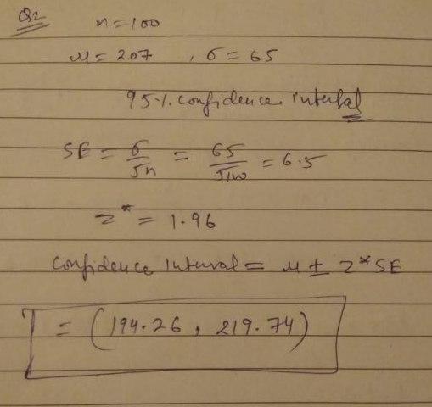

As provided the mean and standard deviation, which is estimating mean using the range to calculate the confidence level. Confidence level calculated –
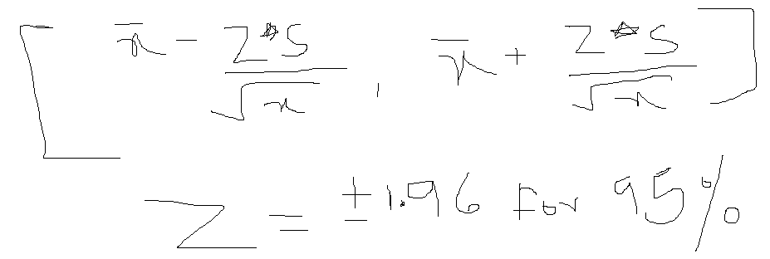

So 95 % is a confidence level for consideration of overall x(population), mean(mu), std. dev. (sigma). As calculated in confidence interval , based on the equation (shown first pic) , so output would be the range in between 194.26, 219.74. So in this range first drop starting with round up value need to consider as sample, to showcase the observations.

Question-3:

a) The painkiller drug needs to have a time of effect of at most 200 seconds to be considered as having done a satisfactory job. Given the same sample data (size, mean, and standard deviation) of the previous question, test the claim that the newer batch produces a satisfactory result and passes the quality assurance test. Utilize 2 hypothesis testing methods to make your decision. Take the significance level at 5 %. Clearly specify the hypotheses, the calculated test statistics, and the final decision that should be made for each method.
b) You know that two types of errors can occur during hypothesis testing — namely Type-I and Type-II errors — whose probabilities are denoted by α and β respectively. For the current sample conditions (sample size, mean, and standard deviation), the value of α and β come out to be 0.05 and 0.45 respectively.
Now, a different sampling procedure(with different sample size, mean, and standard deviation) is proposed so that when the same hypothesis test is conducted, the values of α and β are controlled at 0.15 each. Explain under what conditions would either method be more preferred than the other, i.e. give an example of a situation where conducting a hypothesis test having α and β as 0.05 and 0.45 respectively would be preferred over having them both at 0.15. Similarly, give an example for the reverse scenario - a situation where conducting the hypothesis test with both α and β values fixed at 0.15 would be preferred over having them at 0.05 and 0.45 respectively. Also, provide suitable reasons for your choice(Assume that only the values of α and β as mentioned above are provided to you and no other information is available).

Answer:

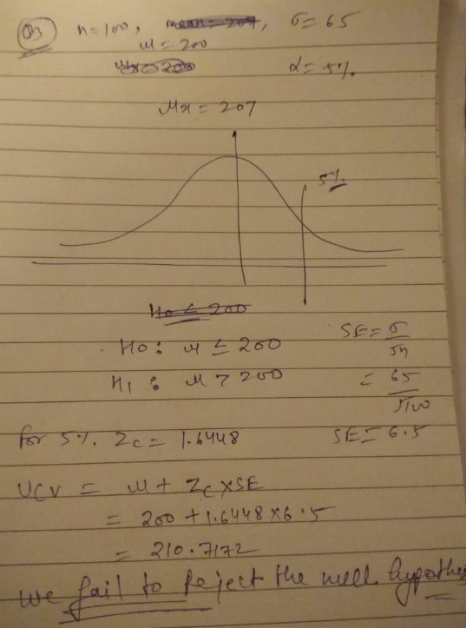

The given values of data first define the Ho and H1 respectively, objective would be to static quo (Ho), challenged by alternate (H1). As looking for the values, sampling mean, standard deviation values are provided, hence we can go with the Z-test terminology. To calculate the same , with the consideration of significance value (5%), standard error and other aspects of sampling population of numbers , mentioned in the equation , and result occurs with 210.71, which is not fulfilling the alternative , hence the conclusion to fail to reject the null hypothesis. Also, right tail significance level defined as 5%, which means the status quo and the result is to close to the population of mean – symmetric mean. Thus, alternative is far more from left and right tail.

Question-4:
Now, once the batch has passed all the quality tests and is ready to be launched in the market, the marketing team needs to plan an effective online ad campaign to attract new customers. Two taglines were proposed for the campaign, and the team is currently divided on which option to use.
Explain why and how A/B testing can be used to decide which option is more effective. Give a stepwise procedure for the test that needs to be conducted.

Answer:

In A/B testing we will divide the whole samples in two equal sample (Sample X and Sample Y) , we will propose each tagline on each sample then compare the results from both the samples , the tagline of samples which gives the larger result will be the tagline which we should be proposed .

